2A2B HUMAN BIOLOGY CELL DIVISION, REPRODUCTION AND HORMONAL CONTROL TEST

Name:_____________________________ Teacher: __________________ /73

Part one – multiple choice

1. Where does fertilisation occur?

a) Uterus

b) Fallopian tube (oviduct)

c) Ovary

d) Vagina

2. What is the function of cilia in the fallopian tube?

a) To provide nutrients for the ova.

b) To produce ova.

c) To lubricate the fallopian tube.

d) To guide ova along the fallopian tube.

3. Why is the endometrium shed at the end of the menstrual cycle?

a) The ova has implanted in the uterus.

b) It is no longer needed because no fertilised egg is going to be implanted.

c) No egg has been released during ovulation.

d) The lining becomes too full of blood and heavy.

4. What is the function of the testes?

a) Produces testosterone and spermatozoa.

b) Makes sperm and oestrogen.

c) Allows sperm to mature before moving into the vas deferens.

d) Produces luteinising hormone and testosterone.

5. Which of the following is **not** true.

a) The male gamete is spermatozoa.

b) The female gonad is the ovary.

c) Gametes are diploid.

d) Gametes are sex cells.

Part two – short answer

1. **List** two things that occur during interphase. (2 marks)

____________________________________________________________________________________

____________________________________________________________________________________

____________________________________________________________________________________

2. **Describe** what happens during cytokinesis. (1 mark)

____________________________________________________________________________________

____________________________________________________________________________________

3. Complete the table below. (10 marks)

|  |  |  |
| --- | --- | --- |
|  | Mitosis | Meiosis |
| The type of cells this occurs in |  |  |
| The number of daughter cells that are produced |  |  |
| The number of divisions |  |  |
| Are the daughter cells genetically identical to the parent cells? |  |  |
| The number of chromosomes in each produced cell |  |  |

4. What is the **difference** between menarche and menopause? (2 marks)

____________________________________________________________________________________

____________________________________________________________________________________

____________________________________________________________________________________

5. List two secondary characteristics that occur in males during puberty. (2 marks)

____________________________________________________________________________________

____________________________________________________________________________________

6. Fill in the table below which shows the phases of mitosis. (12 marks)

|  |  |  |
| --- | --- | --- |
| Phase of mitosis | **Describe** what is happening | Diagram |
|  |  |  |
|  |  |  |
|  |  |  |
|  |  |  |

7. **Label** the diagram below. (3 marks)

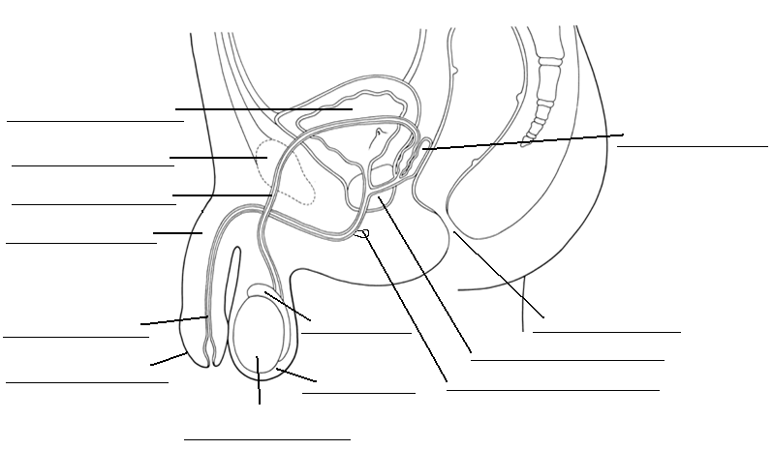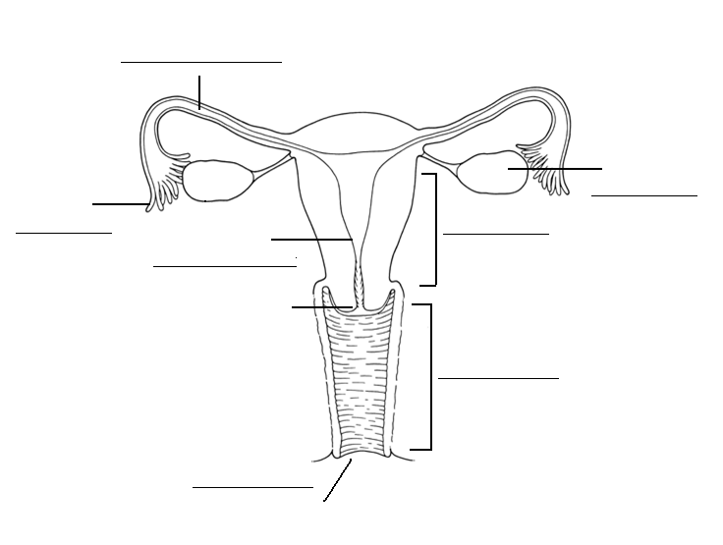8. **Label** the diagram below. (6 marks)

9. Fill in the table below. (6 marks)

|  |  |  |  |
| --- | --- | --- | --- |
|  | Number of gametes produced by meiosis | Do hormones cause meiosis to begin? | When does meiosis occur? |
| Oogenesis |  |  |  |
| Spermatogenesis |  |  |  |

10. Fill in the table below. (12 marks)

|  |  |  |  |
| --- | --- | --- | --- |
|  | Where is it secreted from | Target organ | Effect of hormone |
| FSH |  |  | **⮚**  **⮚** |
| HCG |  |  | **⮚** |
| LH |  |  | **⮚**  **⮚** |

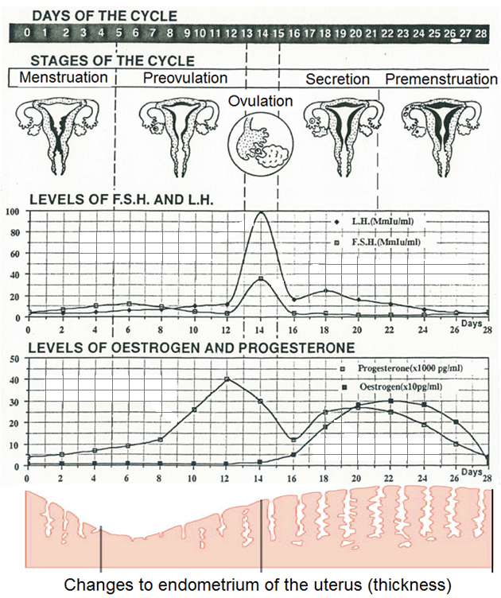Use the diagram below to answer the following questions.

11. Why does L.H peak when it does? (1 mark)

____________________________________________________________________________________

____________________________________________________________________________________

12. What is the function of the corpus luteum? (1 marks)

____________________________________________________________________________________

____________________________________________________________________________________

Part two – extended answer

1. There are a number of steps involved in the production of semen. Starting from the beginning of the process, **describe** the steps taken to produce the final ejaculated product. Include the substances added, where they are added from and what their functions are.

**WRITE IN DOT POINTS PLEASE!**  (10 marks)

___________________________________________________________________________________________

___________________________________________________________________________________________

___________________________________________________________________________________________

___________________________________________________________________________________________

___________________________________________________________________________________________

___________________________________________________________________________________________

___________________________________________________________________________________________

___________________________________________________________________________________________

___________________________________________________________________________________________

___________________________________________________________________________________________

___________________________________________________________________________________________

___________________________________________________________________________________________

___________________________________________________________________________________________

___________________________________________________________________________________________

___________________________________________________________________________________________

___________________________________________________________________________________________

___________________________________________________________________________________________

___________________________________________________________________________________________

___________________________________________________________________________________________

___________________________________________________________________________________________

___________________________________________________________________________________________

___________________________________________________________________________________________

___________________________________________________________________________________________

___________________________________________________________________________________________

___________________________________________________________________________________________

___________________________________________________________________________________________